HAND N BRAIN

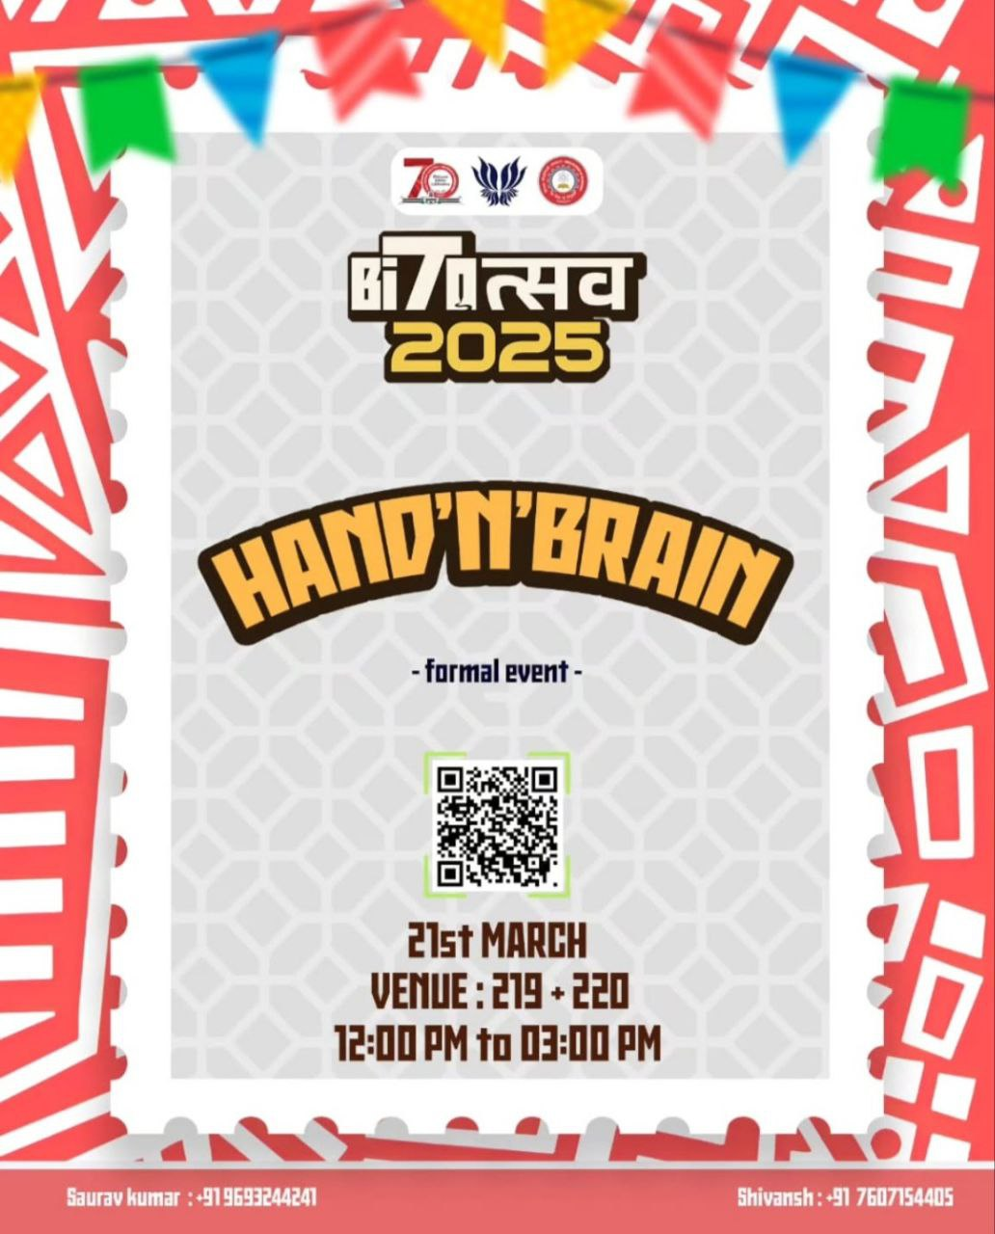

🔥 Hand & Brain at Bitotsav ’25 ♟🧠

Think you know chess? Think again! Hand & Brain is not your typical game—it’s a battle of teamwork, strategy, and trust! One player (the Brain) calls the piece, the other (the Hand) makes the move. Sounds easy? Wait till the pressure kicks in! 🏆

🔮 Can you outplay the chaos? Can you read your teammate’s mind? Test your synergy and checkmate the competition! This unique game challenges you to trust your instincts and work together seamlessly.

♟️ Think you’ve got the perfect synergy? It’s time to put your teamwork and strategy to the test at Hand & Brain! Grab your partner and make every move count. Whether you’re a seasoned chess player or just love a challenge, this is your chance to dominate the board and claim victory!

📍 Event Details:

Event: Hand & Brain @ Bitotsav

Date: 21st March

Time: 12:00 - 3:00 PM

Venue: Room 219 & 220

Register now at bitotsav.com and let the battle begin! 🔥🏆♟️

<https://www.instagram.com/p/DHWrAliTmsz/?igsh=MWMxeW1sbmFibWN2aQ==>

Byte Buildathon

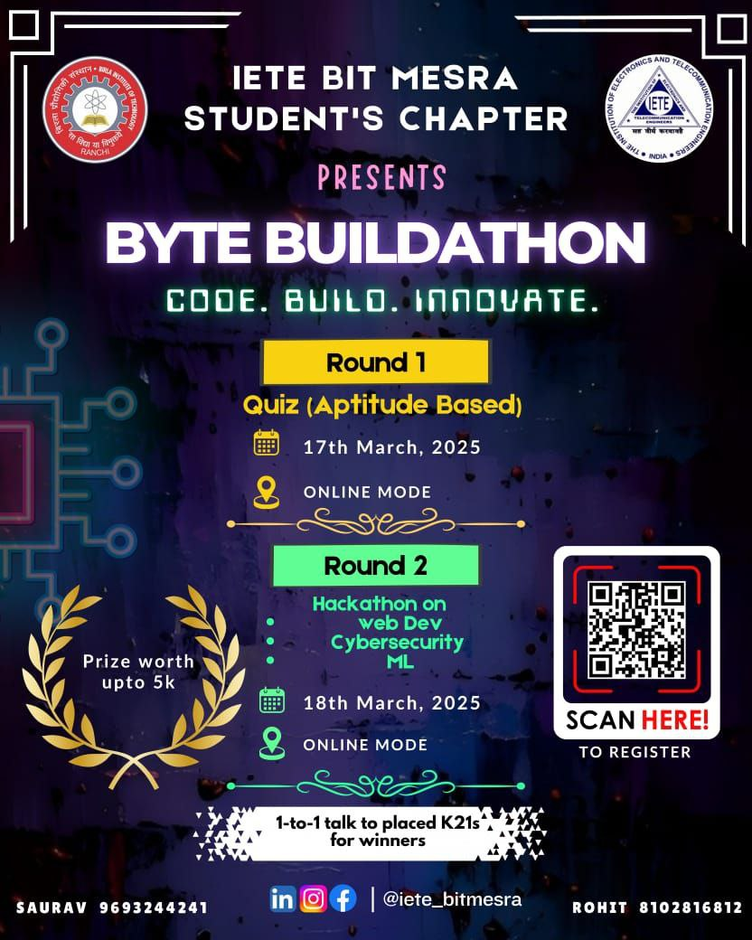

Registration link*: https://forms.gle/R2RV4rGhFgjdAcbP6

Hey folks!!

Are you ready to challenge yourself and showcase your tech skills? Buildathon is here to ignite your creativity and problem-solving abilities! This two-round competition begins with an exciting quiz round, testing your knowledge in tech fundamentals. The selected participants will advance to the hackathon round, where they will work on real-world problems in Web Development, Cybersecurity, and Machine Learning. Whether you are a coding enthusiast or a tech expert, this is your chance to shine!

Participating in buildathon comes with several benefits :

•Get experience: Gain hands-on experience in cutting-edge technologies.

•Compete with enthusiasts: Compete with talented individuals and expand your network.

•Get free mentorship: Get 1-1 mentorship of K21s senior.

•Enhancing resume: Receive a certificate of participation and enhance your resume.

Registrations are now open! Don’t miss the chance to win a cash prize of ₹5000 and prove your skills in this thrilling competition. Register today and be

Connect-o-Thon

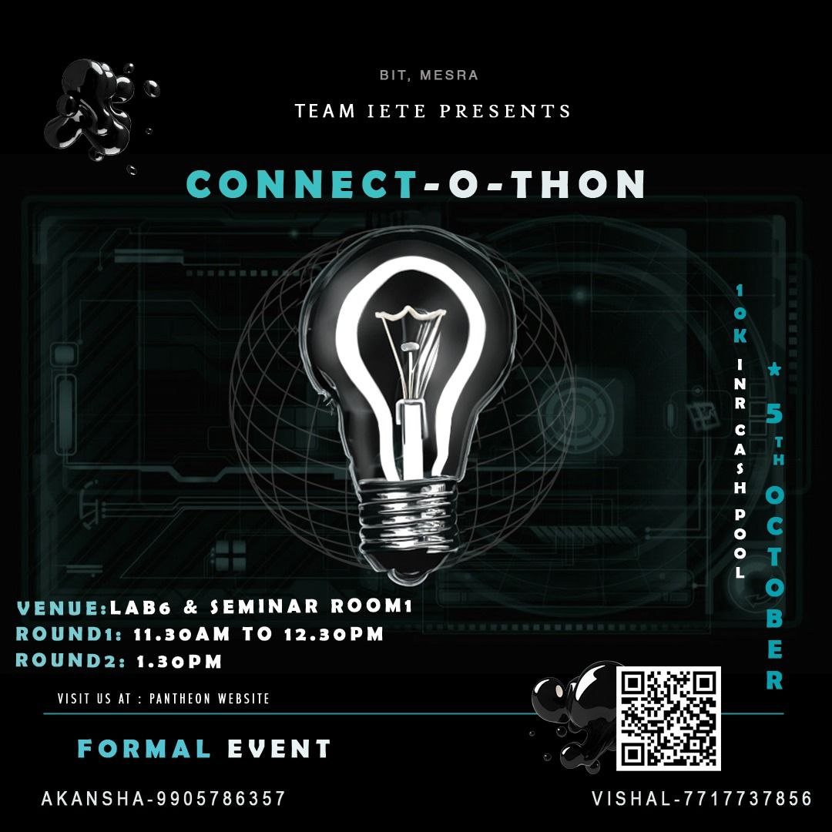

Devquest

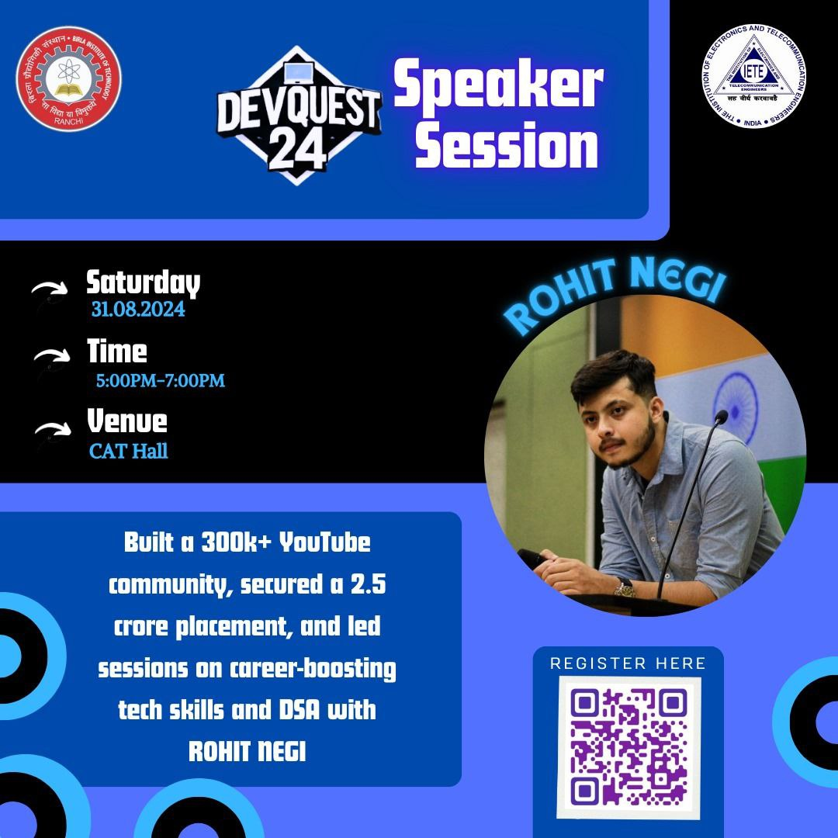

Dive into the world of tech innovation with us at this year’s inspiring session, brought to you by the IETE Students' Chapter in collaboration with founder of Coder Army, Rohit Negi.

As the founder of Coder Army, Rohit is not just a tech expert but also a mentor to thousands of aspiring developers. His YouTube channel, with a combined audience of over 300k subscribers, are a testament to his commitment to sharing knowledge and guiding the next generation of innovators.This session isn’t just about listening, it’s about learning how to overcome challenges. Rohit’s story is filled with practical insights and powerful lessons that can propel your career to new heights.

DevQuest'24 is not just an event; it’s a gathering of bright minds and future leaders in the tech industry. Whether you’re a student, a budding developer, or someone looking to make a mark in tech, this is your chance to connect, learn, and grow.

Registration link for DevQuest '24:

https://forms.gle/4ruGLXQ7eDx5hDqE6

https://bit.ly/DevQuest_speaker_ig